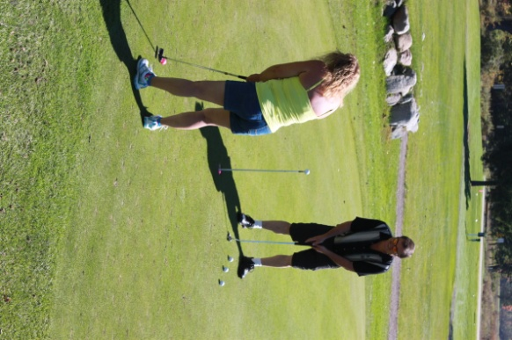
Goodland Township 3rd Annual Golf/Bowling Outing
Join us on Sunday, September 25, 2016 at Holly Meadows Golf Course in Capac, Michigan at 12:00pm.
Bowling only: $3.00 per game, per person
Rental Shoes: $3.00 per person
Dinner Only: $18.00 per person
Children 7 years and up/ Dinner only: $9.00 per child
Children 5 - 7 years/Dinner only: $5.00 per child
Children under 5/Dinner only: Free
